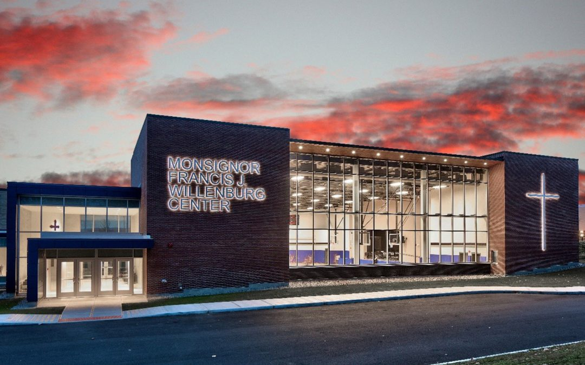

MINIMUM CAPACITY :-
The Minumum intake capacity
of students is between 300-620
children

LIBRARY :-
The Libarary is Available.

CANTEEN:-
The Canteen Facility is Available.

BOARDING :-
No availablility of boarding.

SPORTS :-
There are different categories
sports available.
Girls Volleyball
Boys Volleyball
Football

NOTRE DAME SCHOOLS
UTICA - SCHOOL

School Detail :-
The liberal arts home for all Notre Dame students, with core curriculum courses and electives in everything from theology and philosophy to economics and creative writing. Arts and Letters is Notre Dame’s oldest and largest college or school. Arts and Letters is Notre Dame’s oldest and largest college or school. Arts and Letters is Notre Dame’s oldest and largest college or school. Arts and Letters is Notre Dame’s oldest and largest college or school. Arts and Letters is Notre Dame’s oldest and largest college or school.

